Unveiling Marketing Insights: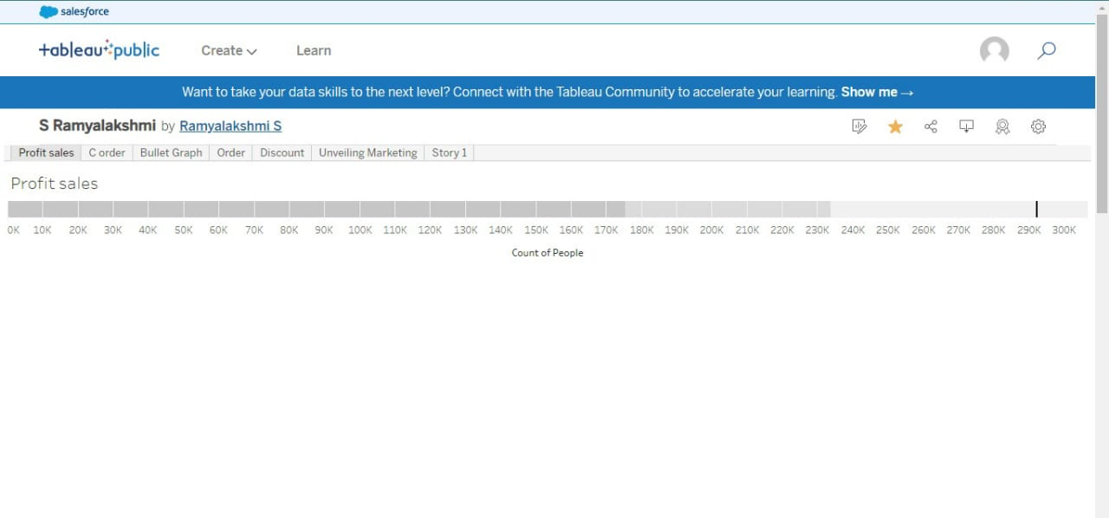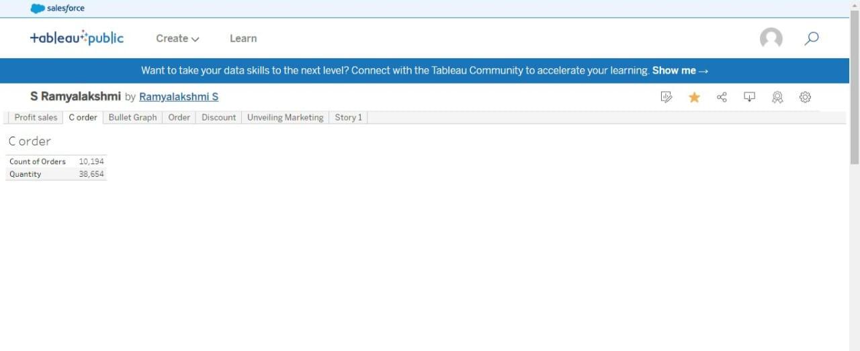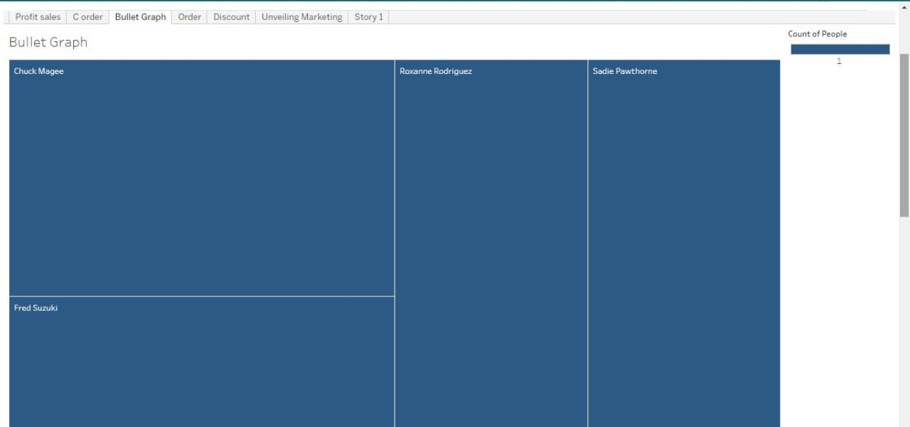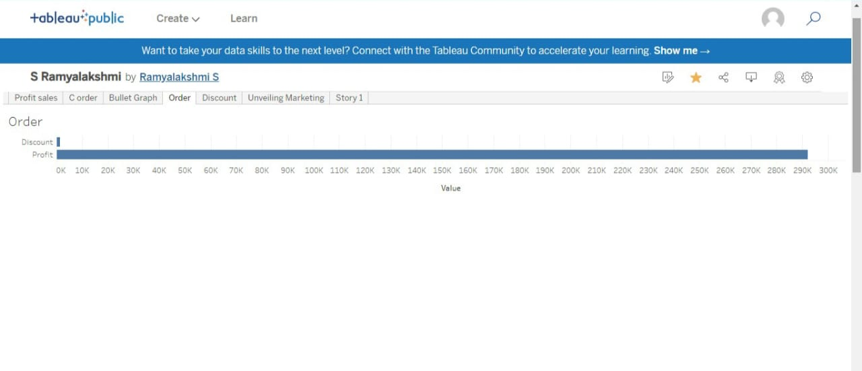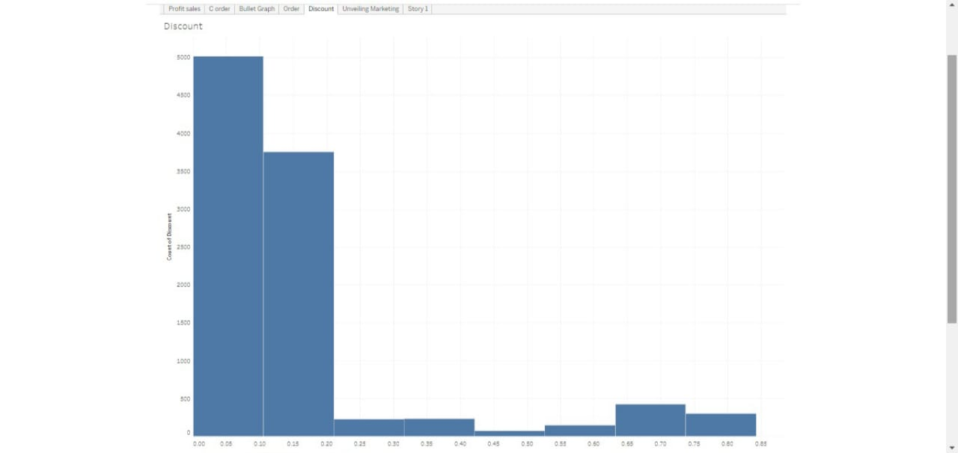

Analysis Spending Behaviour And Identifying Opportunities For Growth.

Project Description

Wholesaling or distributing is the sale of goods to retailer to industrial, commercial, institutional or other professional businessman to other wholesalers (wholesale businesses) and related subordinated services. Wholesaling is buying goods in bulk quantity, usually directly from the manufacturer or source, at a discounted rate. The retailer then sells the goods to the end consumer at a higher price making a profit.

The consumption and production of marketed food are spatially separated. Production is primarily in rural areas while consumption is mainly in urban areas.In today's highly competitive business landscape, gaining deep market insights is essential for businesses to thrive and grow. This project aims to analyze customer spending behavior and identify opportunities for growth by leveraging data analytics and data-driven decision-making.

The primary objective of this project is to understand customer spending patterns, preferences, and trends across various dimensions.. By conducting a comprehensive analysis, businesses can optimize their marketing strategies, improve product offerings, and enhance customer engagement to drive revenue growth